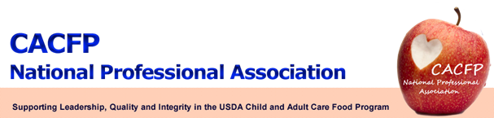
March 2015 Message of the Month
USDA Update
USDA is still accepting comments on the proposed CACFP Meal Patterns until April 15, 2015. Please submit your comments through the Federal ERulemaking Portal located at:
http://www.regulations.gov

FRAC Update
FRAC held its 2015 National Anti-Hunger Policy Conference March 1-3, 2015 in Washington, DC.

Strategic Planning Meeting
The NPA Board held a strategic planning meeting on March 17 -18, 2015 in Raleigh, NC.
The Strategic Planning was facilitated by Alice Lenihan, former Nutrition Services Branch Head in North Carolina. The planning session was quite productive. The Board identified that NPA should influence: CACFP state employees, Affiliate members, Institutions, USDA and Congress. The Board identified Communicating with NPA members and Marketing NPA as the two top priorities.
- Communication with NPA members by:
- Website
- Social media; webinars; surveys
- Message of the month

- Marketing NPA by:
- Emphasize the goal is to partner and inform
- Market to USDA to be able to reach the highest level of management
- Obtain professional marketing advise

Membership
Discussion was held to consider different levels of membership such as: retired, affiliate, institution, and corporate membership.

National CACFP Week
NPA is in full support of making the third week of March National CACFP week!

